Ảnh màn hình đã đẩy file lên git hub:

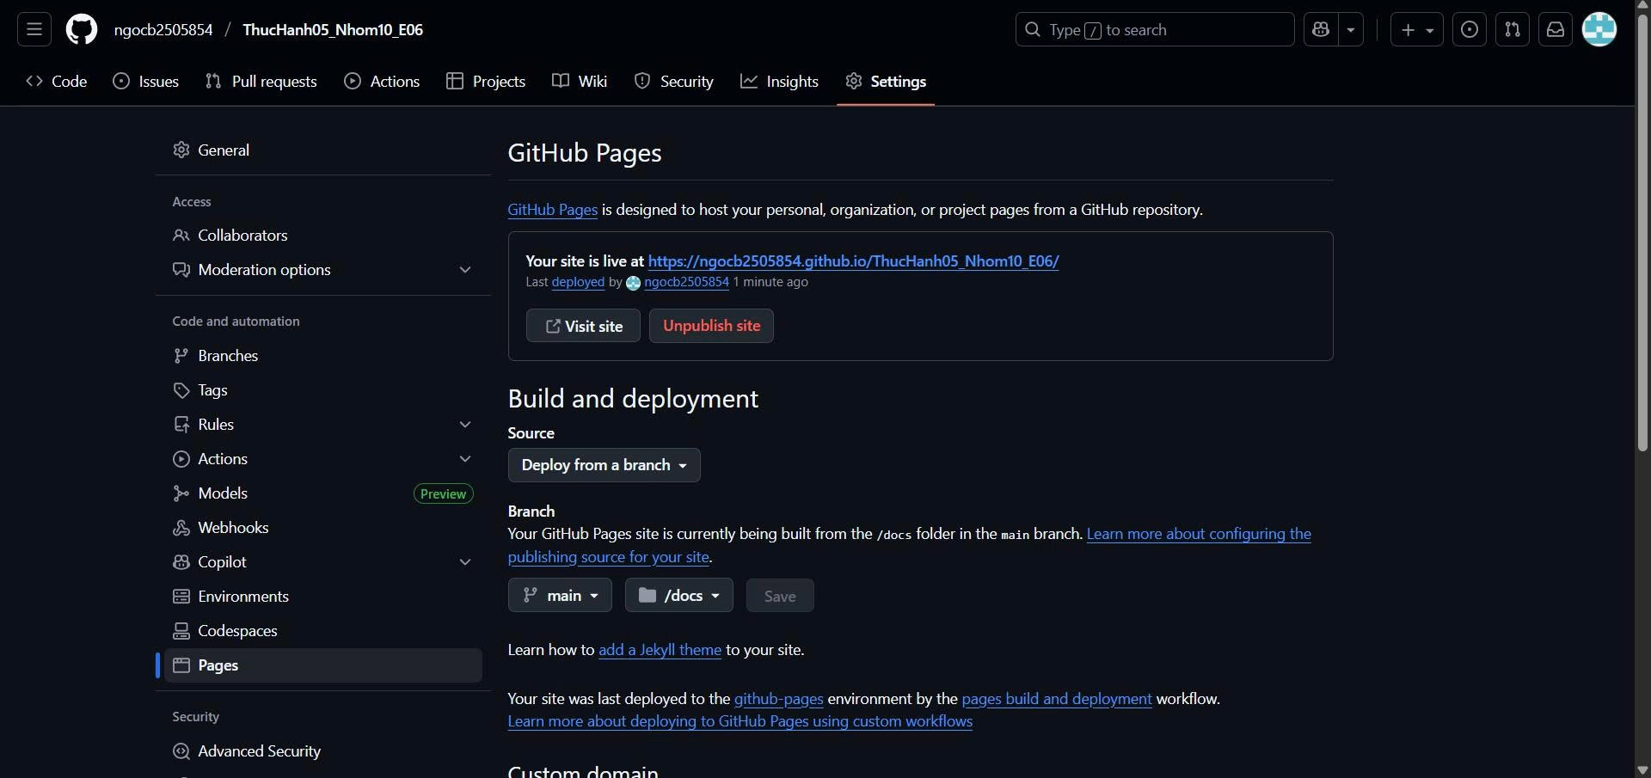

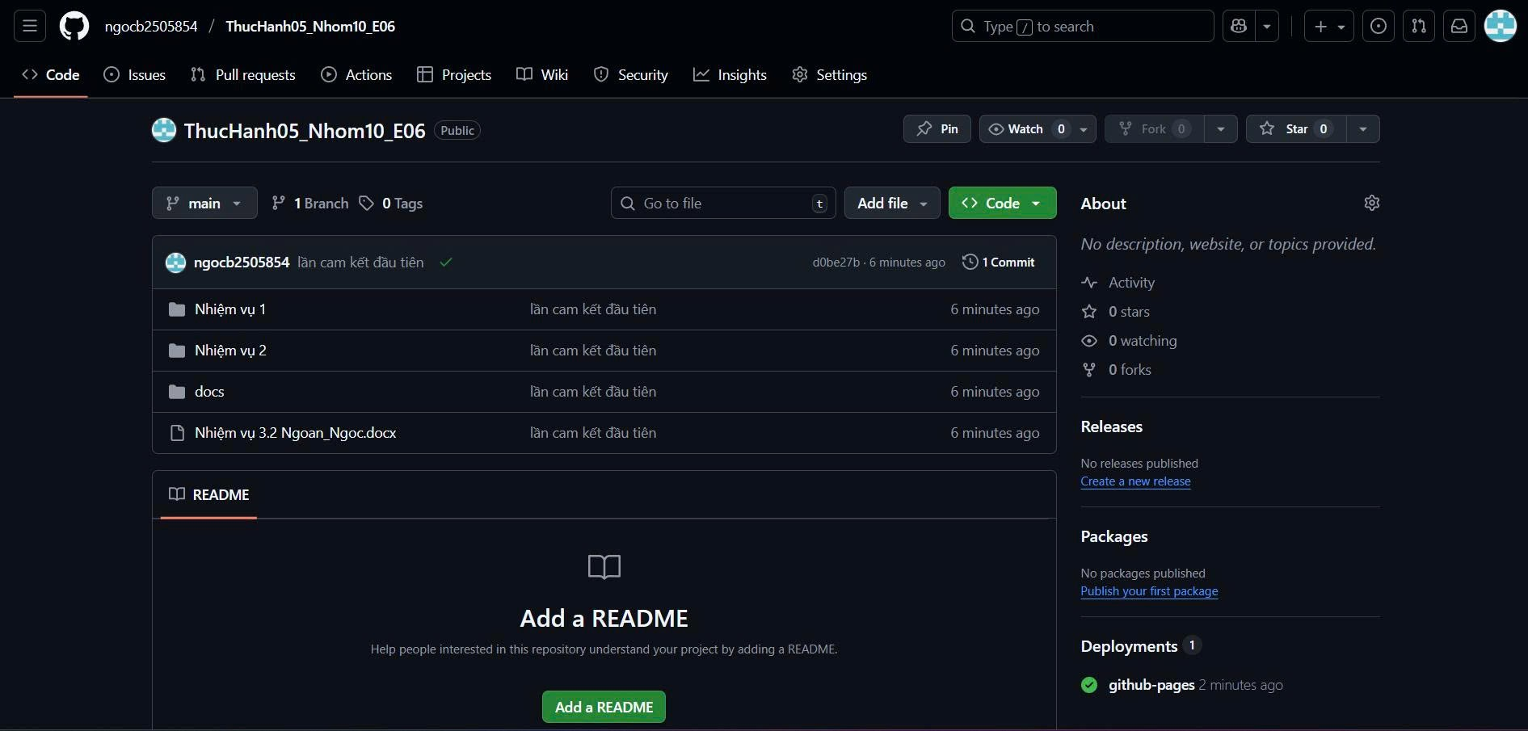

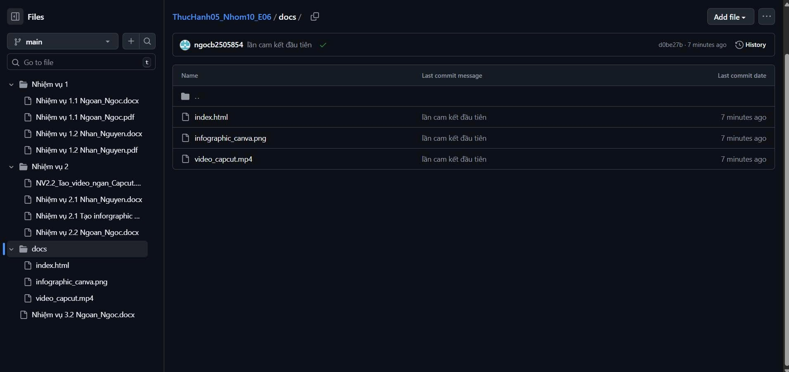  
Link Microsoft Teams: <https://teams.microsoft.com/l/channel/19%3AMBKWd3Eg_3gczhpITs5qVzgJZQ7JdlTe5XsPxRyqeIA1%40thread.tacv2/General?groupId=78224c53-6907-4c2b-af5e-6f602d23d29f&tenantId=80a906da-b4ca-4ccb-81c3-d0b567529534>

Link github: <https://github.com/ngocb2505854/ThucHanh05_Nhom10_E06.git>

Link trang web đã public: <https://ngocb2505854.github.io/ThucHanh05_Nhom10_E06/>